## Photographic Essay: Water Scarcity in African Communities

### Introduction: The Unseen Crisis, The Unbreakable Spirit

Water is life; however, for millions in African communities, access to this vital resource is a daily challenge. This photo essay hopes to explore the widespread issue of water scarcity to express the harsh realities, consequences, and ultimate resilience and ingenuity of communities thirsting for water security. Through these images, we tell a story of suffering and survival, and the hope that one day clean water flows freely.

### Section 1: The Harsh Reality

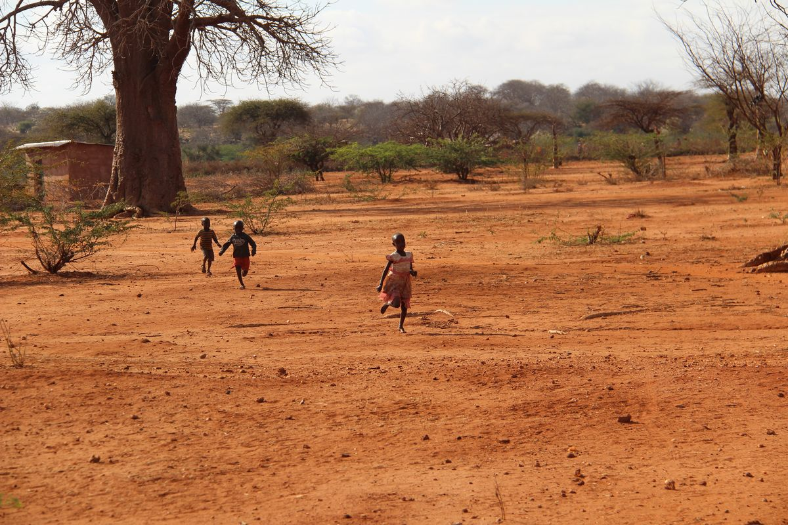

* **Caption:** The relentless sun bakes the land, leaving behind a mosaic of cracked earth in a once-fertile riverbed. This stark landscape is a common sight, signaling the severe lack of rainfall and persistent drought that grips many regions.

**Photo 2: Withered Crops**

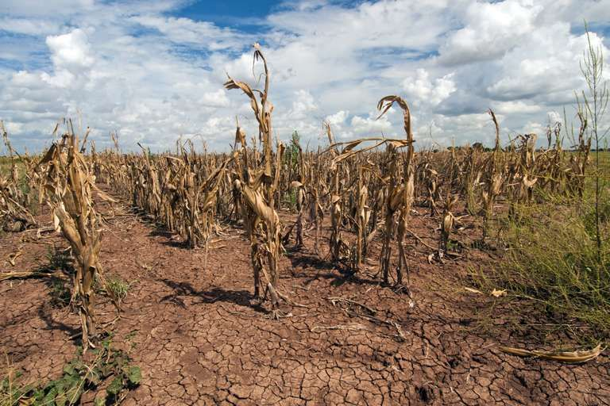

* **Caption:** Fields that should be green and abundant lie barren, their crops withered and unproductive. For farming communities, this means lost livelihoods and the ever-present threat of food insecurity.

**Photo 3: Empty Jerrycans**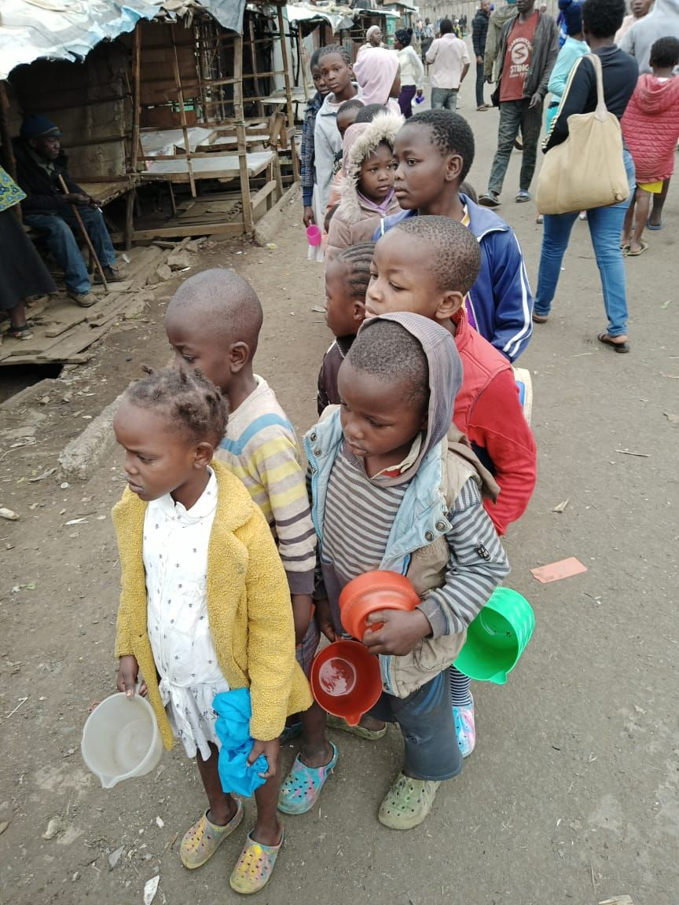

* **Caption:** A silent testament to unmet needs, these empty jerrycans wait patiently, hoping for the day they can be filled. They symbolize the constant quest for water that defines daily life.

**Photo 4: The Dusty Path** 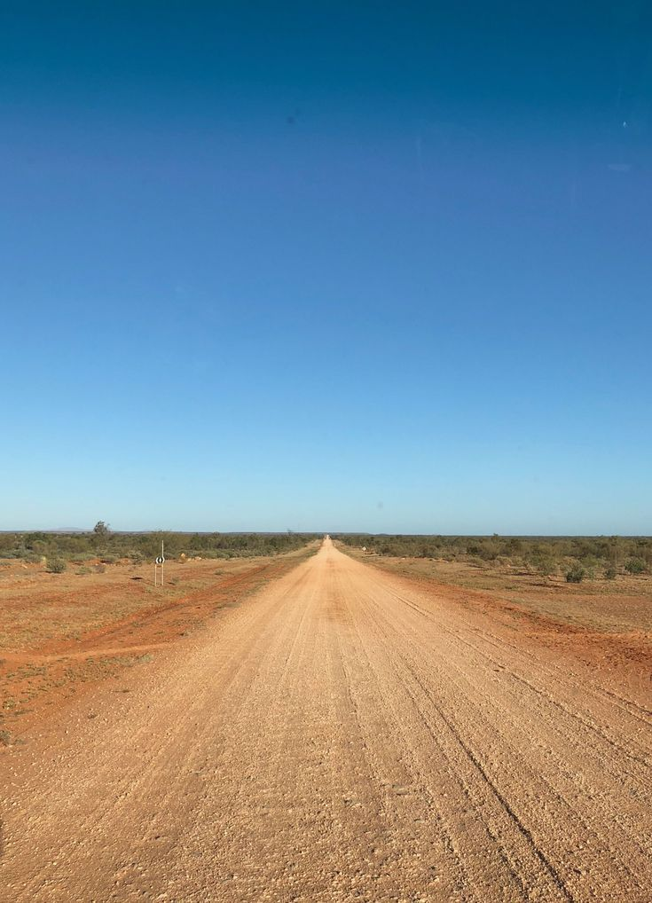

* **Caption:** Miles of dusty paths separate communities from their nearest water sources. Every step on this arduous journey underscores the physical toll and time consumed in the pursuit of water.

### Section 2: The Daily Struggle & Impact

(These photos illustrate how water scarcity directly affects daily life, particularly for vulnerable populations.)

**Photo 5: The Long Walk for Water**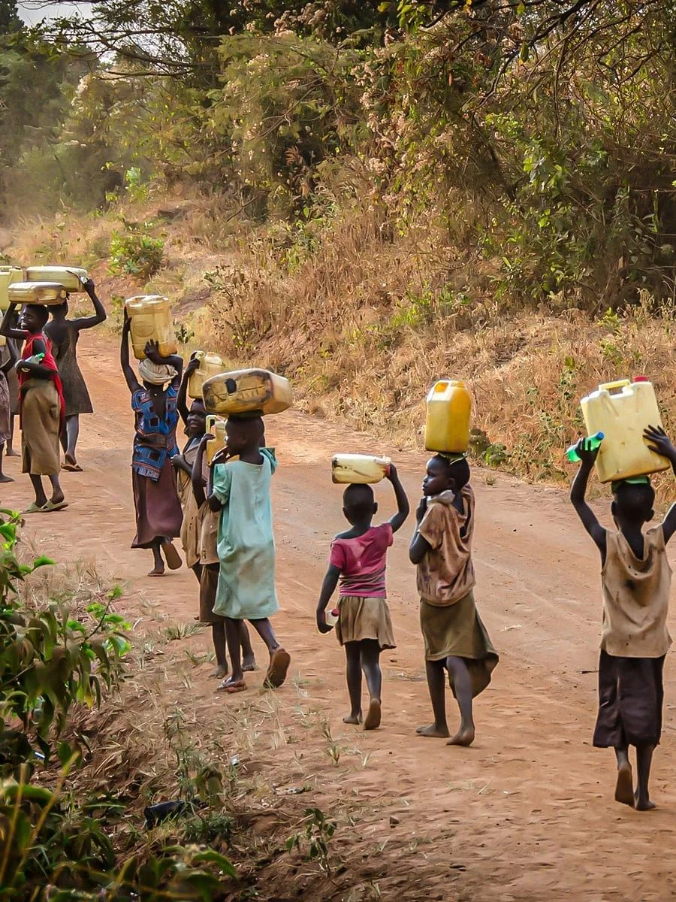

* **Caption:** Often, it is women and children who bear the primary burden of water collection, walking for hours under the scorching sun to fetch water for their families. This journey steals time from education and other productive activities.

**Photo 6: Queue at the Borehole**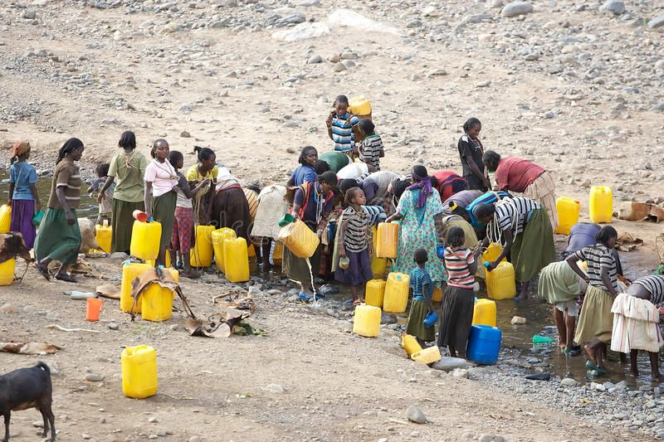

* **Caption:** Long queues at the communal borehole are a daily ritual, a stark reminder of the limited access and the preciousness of every drop.

**Photo 7: Unsafe Water Source**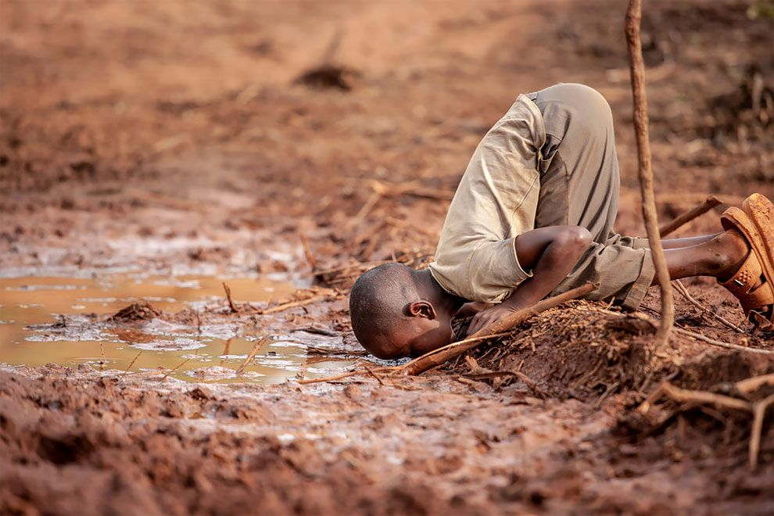

* **Caption:** When clean sources are scarce, communities are forced to rely on unsafe water, often from muddy puddles or contaminated rivers. This practice, though risky, is a desperate measure that leads to widespread water-borne diseases.

**Photo 8: Child Missing School**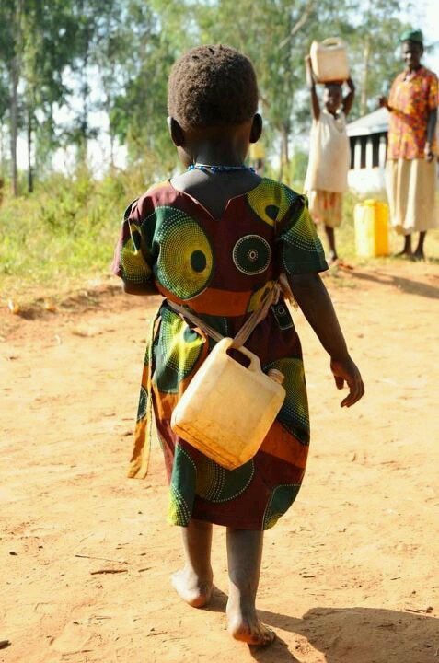

* **Caption:** The quest for water often means missed school days for children, particularly girls. Their education is sacrificed as they contribute to the family's most basic survival need.

**Photo 9: Livestock Seeking Water**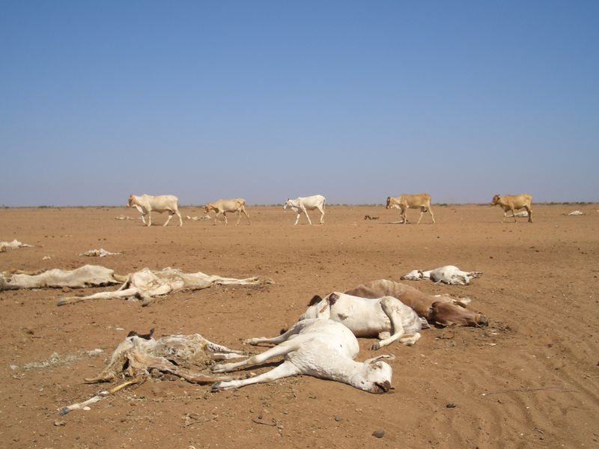

* **Caption:** The impact extends beyond humans. Livestock, vital for livelihoods, also suffer immensely, struggling to find sustenance in parched lands, further exacerbating economic hardship for pastoralist communities.

### Section 3: Resilience & Community Coping

(These photos highlight the strength, ingenuity, and collective efforts of communities in coping with water scarcity.)

**Photo 10: Community Well Digging**

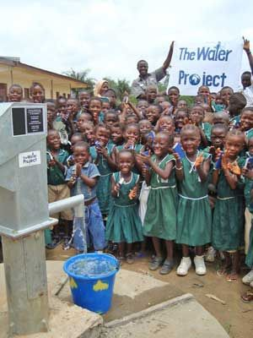

* **Caption:** In the face of adversity, communities unite. Here, villagers pool their strength and resources, collaboratively digging a new well, embodying the spirit of collective action and hope.

**Photo 11: Innovative Rainwater Harvesting**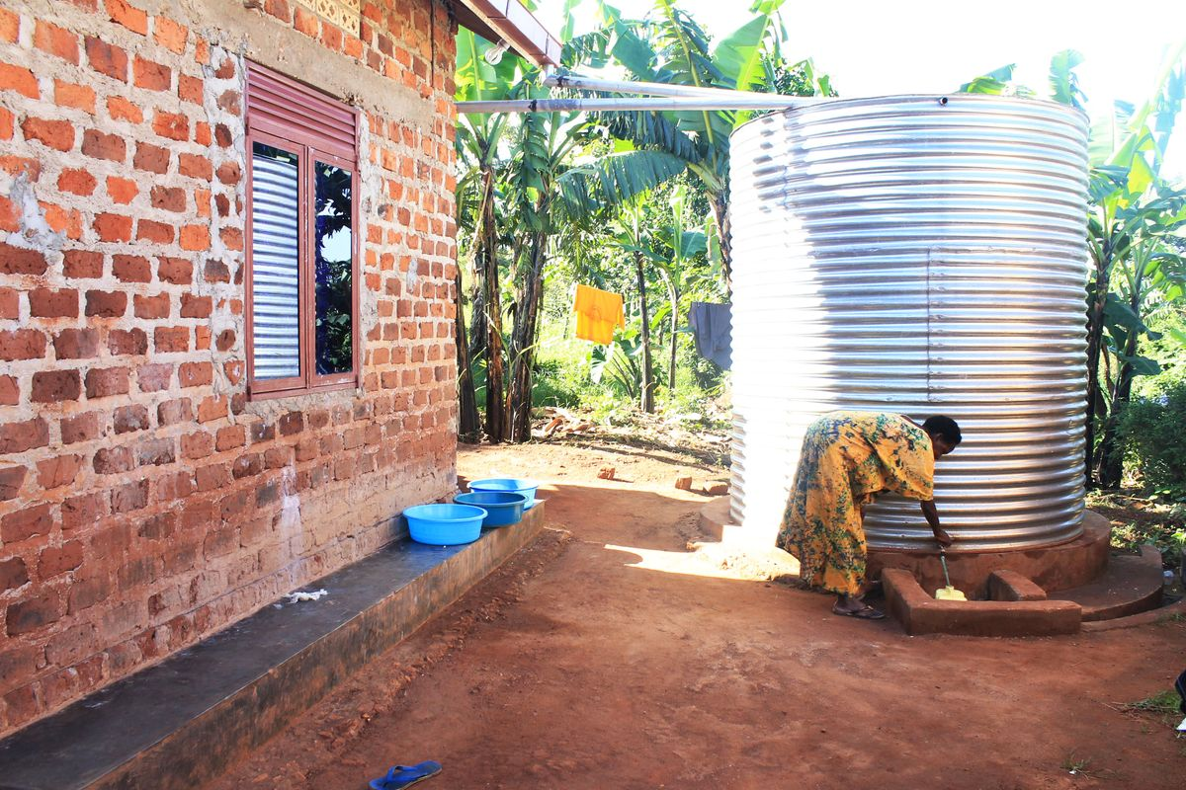

* **Caption:** Ingenuity blossoms in scarcity. This family has implemented a simple rainwater harvesting system, capturing precious drops during the rainy season for future use, demonstrating resourcefulness and forward-thinking.

**Photo 12: Traditional Water Storage**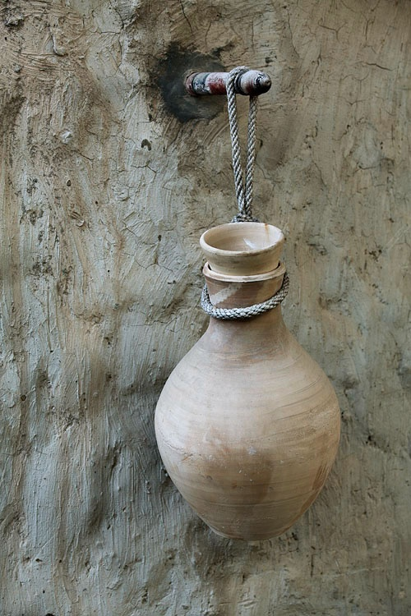

* **Caption:** Ancient wisdom meets modern challenges. Traditional methods of water storage, like these large clay pots, help keep water cool and accessible, a testament to enduring cultural practices.

### Section 4: Solutions & Hope

*(These photos showcase efforts and advancements towards providing sustainable water access and a brighter future.)*

**Photo 13: New Borehole, Clean Water**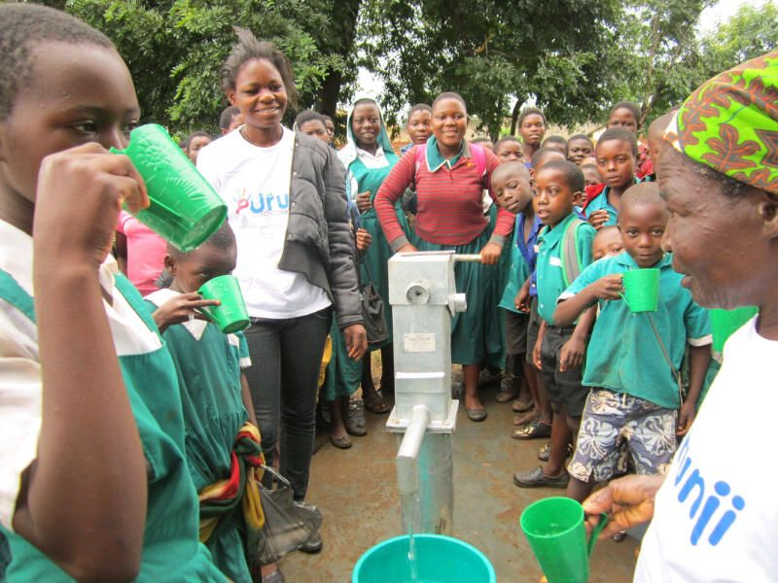

* **Caption:** A beacon of hope: a newly installed borehole brings clean, safe water directly to the community. This vital infrastructure transforms lives, reducing journeys and improving health.

**Photo 14: Solar-Powered Pump**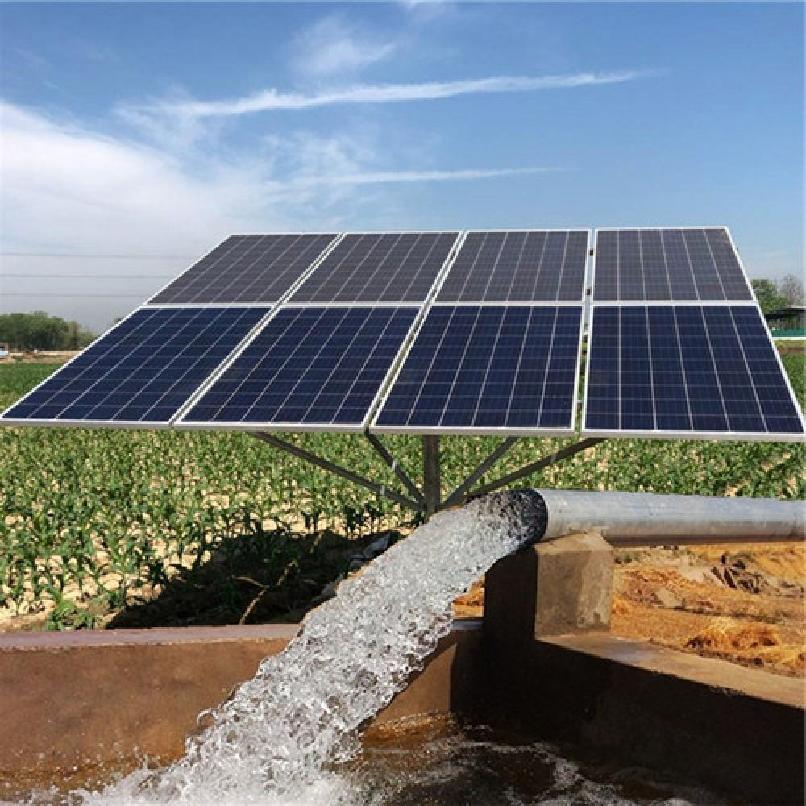

* **Caption:** Technology meets sustainability. A solar-powered pump efficiently draws water from underground, providing a reliable and environmentally friendly solution for consistent water access, showcasing innovation in action.

**Photo 15: Water Education in Schools**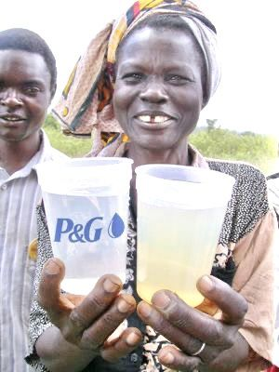

* **Caption:** Educating the next generation: children learn about water conservation and hygiene practices in school. Knowledge empowers them to be stewards of this precious resource.

**Photo 16: Thriving Community with Water Access**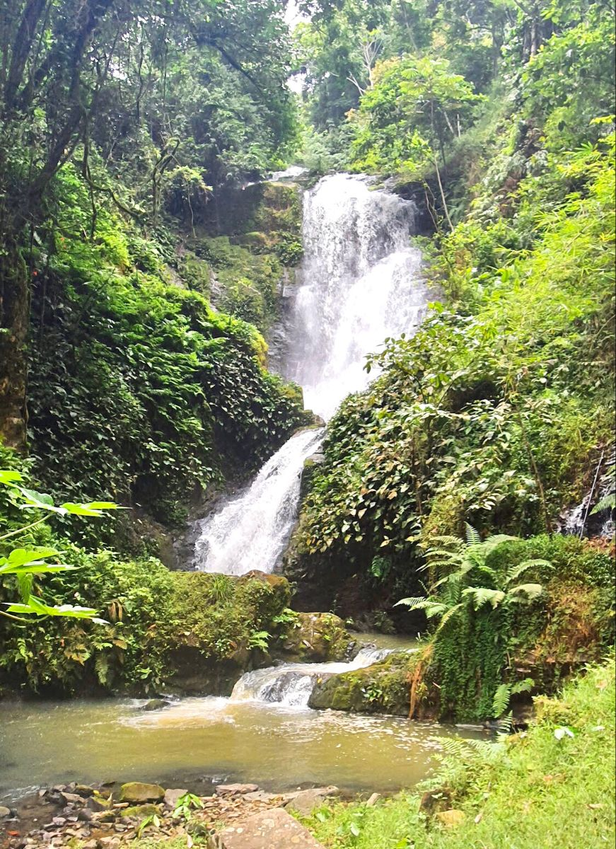

* **Caption:** The transformative power of water. With consistent access to clean water, communities flourish, leading to healthier families, thriving gardens, and renewed hope for a prosperous future.

### Conclusion: A Future Flowing with Hope

The journey through these images reveals the stark realities of water scarcity but also illuminates the incredible resilience, ingenuity, and determination of African communities. While the challenge is immense, the ongoing efforts to implement sustainable solutions, often powered by technology, offer a clear path towards a future where clean water is not a luxury but a universal right. This essay serves as a call to action, reminding us of the critical need for continued investment, innovation, and collaboration to ensure water security for all, fostering healthier, more prosperous, and sustainable communities across Africa.

## Conclusion: A Call to Action

The water crisis in Africa is not just an African issue; it is a global crisis that must be urgently addressed and continually, decisively acted upon. The faces in the pictures represent millions of people in Africa who would benefit from something as easy as turning a tap.

We have the solutions for improved infrastructure, community-based management, rainwater harvesting and improved irrigation systems. What is needed now is the political will, necessary financing and global partnerships to make clean water an accessible reality for every person, everywhere.

Every photograph tells a story of human dignity, in the face of adversity. These are not just numbers and statistics, they are mothers, fathers, children and entire communities all limited by the absence of clean water.

The issue is not whether we can solve the water crisis in Africa, it is whether we have the will to do so collectively. The time to act is now.

## Key Statistics

* 400 million people in sub-Saharan Africa do not have basic access to drinking water
* Women and girls shoulder 70% of the burden of water collection
* 297,000 children under 5 die every year in Africa from water related diseases
* Six hours is the average daily time spent collecting water.
* Only 24% of sub-Saharan Africa has access to safely managed drinking water.
* $1 of investment in water infrastructure returns $4-12 in economic benefits.

## How to Help

One of the ways to help is to support organizations working on improving water access all over Africa, advocate for policy changes, and raise awareness about the problem. Water is a human right and let’s all work to make this right a reality.

*This photographic essay is meant to highlight one of Africa's most urgent challenges. In doing so, we also aim to celebrate the strength and resilience of the communities affected. Through impactful images and narratives, we hope to motivate action and support for sustainable water solutions throughout Africa.*